Module: 1 (SDLC)

1. What is software?

- It's a set of instructions that tell the computer what to do. It includes things like apps, games, and even the system that makes everything work together.

.what is software engineering?

-It's about designing, creating, and maintaining software using structured methods and tools to ensure it works well, is reliable, and meets the needs of its users.

2.Explain types of software

-Eg.of softwares, applicatin software: powerpoint, system software: ios/android, driver software: audio drive/video drive, middleware: Microsoft office, programming software: sublime.

3.What is SDLC? Explain each phase of SDLC

-SDLC stands for Software Development Life Cycle. It's a process used by software developers to design, develop, and test high-quality software.

-Here are the phases of SDLC:(1)PLANNING for making the website, (2)ANALYSIS the products that will be used, (3)DESIGNING how the site will be looking, (4)IMPLEMENTATION design based coding, (5)TESTING run the site if any issues then noted down, (6)MAINTENANCE for any updates or any miss fault.

4. What is DFD? create a DFD diagram on Flipkart

-A Data Flow Diagram (DFD) is a visual representation that shows how data flows through a system or process.

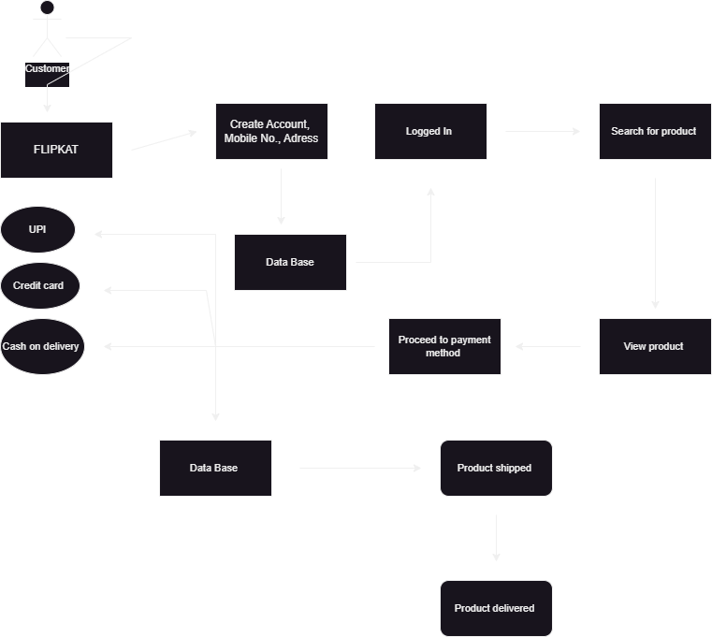

5.What is a flow chart? create a FLOWCHART to make addition of two numbers

-A flowchart is like a map that shows the steps of a process or how things work. It uses symbols like arrows and shapes to explain each step and how they connect together.

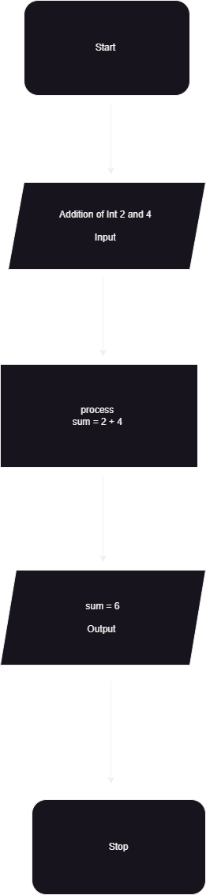

6.What is Use case Diagram? Create a use-case on bill payment on paytm

- A use case diagram is a diagram that shows interactions between users (called actors) and a system, displaying the different tasks (called use cases) each user can perform with the system. It helps visualize how users will interact with the software or system.

